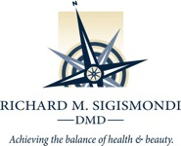
8 MUNSON LANE
WEST SAYVILLE, NEW YORK 11796
631-563-1583
DrSigismondi@drsigismondi.com

ACKNOWLEDGEMENT OF RECEIPT OF NOTICE OF PRIVACY PRACTICES

I, ________________________________________________ have received a copy of this office’s Notice of Privacy Practices.

(Please Print Name)

(Signature) (Date)

For Office Use Only

We attempted to obtain written acknowledgement of receipt of our Notice of Privacy Practices, but acknowledgement could not be obtained because:

( ) Individual refused to sign

( ) Communication barriers prohibited obtaining the acknowledgement

( ) An emergency situation prevented us from obtaining acknowledgement

( ) Other (Please specify)

____________________________________________________________________________________________________________________________________________________________________________________________________________________________________________________________________________________________________________________________________________________________

